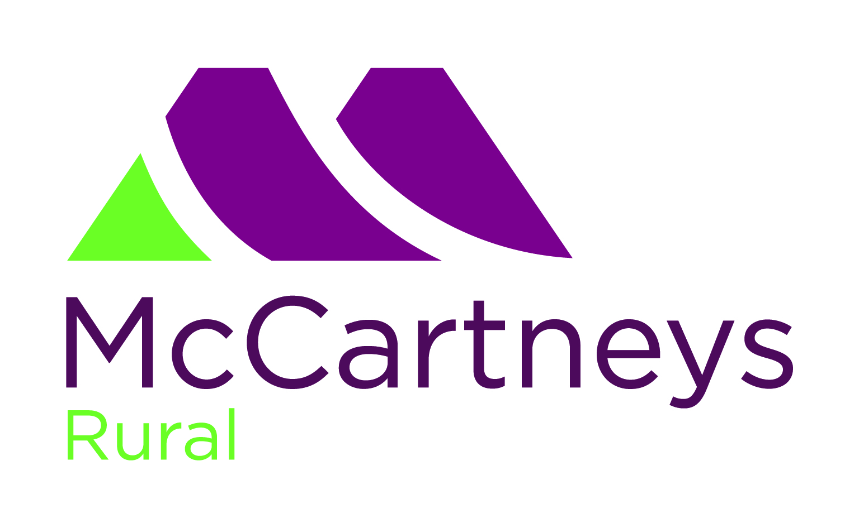

SCHEDULE

NATIONAL SOUTHDOWN PREMIER SALE
Top Drawer Pedigree and Commercial Males and Females

Held under the Auspices of the Southdown Sheep Society
at

Worcester Market
on
Saturday 7th August 2021
Closing Date for Entries Monday July 12th 2021

Sale Venue
WORCESTER MARKET (adjacent to M5 motorway), The Heath Meadow, Nunnery Way,
Worcester. WR4 0SQ CPH 17/521/8001
Sale Organisers
McCartneys
The Heath Meadow, Nunnery Way, Worcester, WR4 0SQ
Tel: 01905 769770 Fax: 01905 769772
email: worcester@mccartneys.co.uk

Friday 6th August 2021 | Arrival of Sheep | 4.00 pm – 6.00 pm
Saturday 7th August 2021 | Arrival of Sheep  Veterinary Inspection | 6.00 am – 9.00 am  No sheep should arrive after this time  8.00 am – 9.00 am
 | Judging of Show Classes | 10.30 am
 | Sale Commences | 12.30 pm
Entry Fees | £6 per head incl. VAT  Entry cheques made payable to McCartneys  Please note:  Entry form & payment must be sent to McCartneys
Commission | All Lots will be sold in guineas. Commission will be 5% charged to the vendor with a minimum commission of £2 per Lot. Half commission will be charged on all unsold Lots based on reserve prices.

Society Levy | The Southdown Sheep Society will charge a 2% sale levy to all vendors deducted at source by the Auctioneers.
General Conditions and Statutory Regulations | The event will be carried out in full compliance with DEFRA and other statutory regulations in place at time of the Sale.
All Entries | All entries must be tagged in accordance with current DEFRA regulations. Tag numbers must correspond to Pedigree Flock Book entries. Substitutes will be allowed at a rate of one per vendor per section Any animal, apart from a substitute, whose ear tag does not match that printed within the catalogue will be rejected from the Sale.  Sheep will be sold through a sale ring.  LATE ENTRIES CANNOT BE ACCEPTED  PLEASE NOTE CURRENT UPSET PRICES
Animal Health | Entry to the Sale carries a warranty of soundness from the vendor. In the case of sheep in respect of mouth, udder and breeding capability and that female sheep over two years have bred a lamb.
MV Accredited | Provision will be made for MV Accredited sheep. Vendors will be responsible for indicating on the entry form their status.
Society Inspection | All entries will be subject to Breed Society inspection and weighing.
Transport of Animals | All animals must be transported in vehicles or trailers which comply with the current law. There will be washing out facilities at the market. No animals will be allowed on to the sale ground other than those entered within the Sale.
Straw and Water | All pens will be strawed up in advance. Vendors should supply their own feed buckets etc. Water is available at the market.
Overnight Stay | Caravans, tents and trailers may be used for sleeping in.
Reserve Price | Any reserve prices must be submitted to the Auctioneer in writing prior to the sale of Lots.

SHOW CLASSES (max 2 Entries per Exhibitor per Class)
Sheep to be entered for Show on the day
Judge: Nick Page, Goodwood.

CLASS 1 Ewe Lamb (born 2021)
CLASS 2 Shearling Ewe
CLASS 3 Ram Lamb (born 2021)
CLASS 4 Shearling Ram
Please note there are no classes for older sheep

The sheep will be judged out of the pens on halters.
Please ensure your entries meet the required breed standard and minimum weights.

