Southdown Signet Group
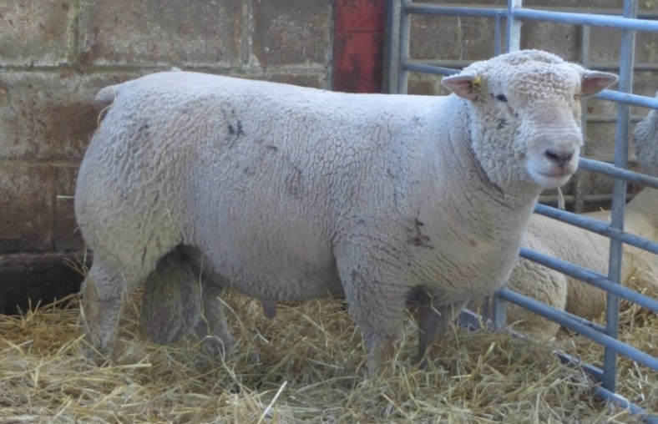
Signet are proud to work with the Southdown Signet Group. The group consists of some of the top Southdown breeders in the UK who meet annually with Signet staff and work together to promote Southdown genetics to commercial breeders. The group performance record their stock to produce estimated breeding values (EBVs) which are then used to accelerate genetic progress within their flock and sell Southdown rams to commercial buyers.
Commercial ram buyers are increasingly buying rams with good EBVs, and the Southdown Signet Group provides Southdown genetics to the growing market. The EBVs supply buyers with performance and genetic information on their prospective ram so the buyer can select a Southdown ram that will improve the growth rate, carcass quality and composition of their slaughter lambs. The genetic evaluation gives breeders another tool to aid selection – breeders are no longer choosing stock on looks alone!
The group is open to all Signet recorded flocks and members with at least two year’s recording contribute to the group’s marketing costs. If you are interested in joining the Southdown Signet Group contact Patrick Goldsworthy, Email: patrick@goldsworthy-uk.com Telephone: 07711 416312. The group also has its own website www.signetsouthdowns.com.
New Recording Fees
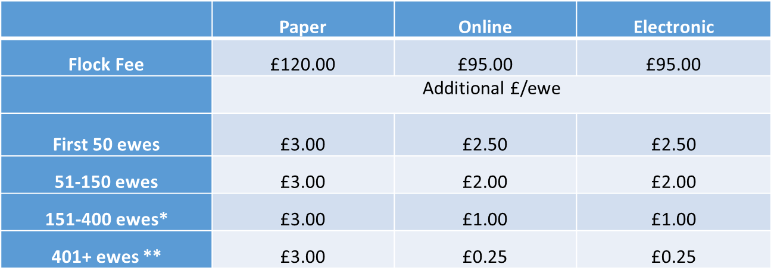
Signet are introducing new better value performance recording fees from lambing 2017. The new structure will reward breeders who submit data to Signet online or electronically (via Excel spreadsheet) with cheaper fees. Recording costs have fallen by £50-100 per flock and in the case of large flocks even more. The annual scanning fee is an additional £175 minimum covering the first 100 lambs, thereafter it is £1.75 per lamb.
*paper based services will no longer be offered to new clients with over 250 ewes
**Fees will no longer be capped at £800

Full instructions on how to submit data can be found on the Signet website or contact Emma Steele for further assistance at Emma.Steele@ahdb.org.uk.

