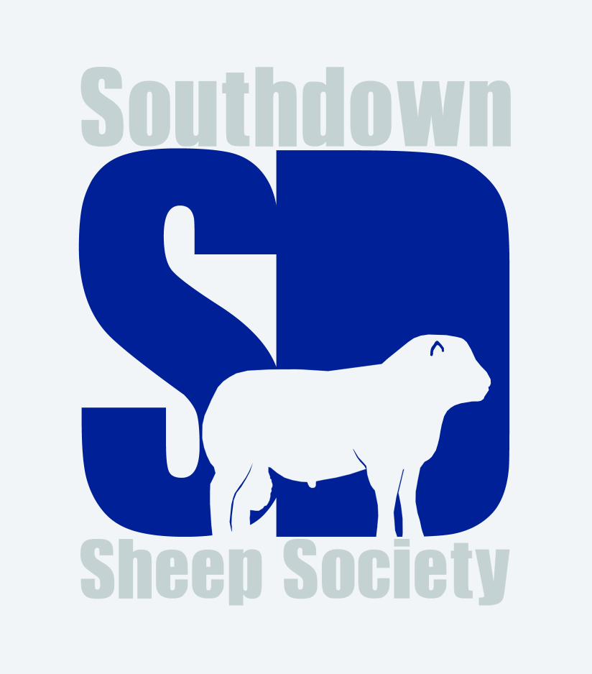

Royal Bath and West Show 2022

Aged Ram
- Jonathan Long
- Phil Tucker
- Wowie Dunnings
- Wowie Dunnings
- Joshua Farrell

Shearling Ram
- Wowie Dunnings
- James Leonard and family
- Joshua Farrell
- Nicky Jesse

Ram Lamb
- Megan Chilcott
- Annabel Halcrow
- Jonathan Long
- Sophie Long
- James Leonard and family

Aged Ewe
- Jonathan Long
- Phil Tucker
- Phil Tucker
- Wowie Dunnings
- Sophie Long

Shearling Ewe
- Jonathan Long
- James Leonard and family
- Wowie Dunnings
- Megan Chilcott
- Megan Chilcott

Ewe Lamb
- Annabell Halcrow
- Jonathan Long
- Megan Chilcott
- James Leonard and family
- Wowie Dunnings

Group of Three
- Jonathan Long
- Phil Tucker
- Wowie Dunnings
- Annabell Halcrow

Champion – Megan Chilcott’s ram lamb
Reserve champion – Jonathan Long’s shearling ewe

Reserve native shortwool interbreed champion – Megan Chilcott’s ram lamb
Reserve native shortwool interbreed group of three – Jonathan Long
Interbreed native shortwool team of six champion – Messrs Long and Halcrow

