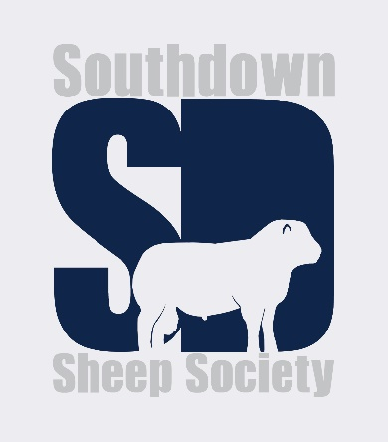
SOUTHDOWN SHEEP SOCIETY
Election of Council Members - 2021
To vote, mark an X against the candidates you wish to support.
You may vote for no more than FOUR candidates.

Lindsay Dane
Patrick Goldsworthy
Tim Morris
Nick Page
Neil Stainthorpe

Signature…………………………………………
Name……………………………………………..
Flock number……………………………………
Date………………………………………………

Please return your completed voting paper to
The Southdown Sheep Society office, Meens Farm, Capps Lane, All Saints, Halesworth, Suffolk, IP19 0PD no later than midday on September 11th 2021, by post or email.
Please note that members attending the AGM and Field Day on September 18th 2021 may vote in person. Membership subscription must be up to date in order to be eligible to vote.

